|  |  |  |  |  |  |  |  |  |  |  |  |  |
| --- | --- | --- | --- | --- | --- | --- | --- | --- | --- | --- | --- | --- |
| **Software Requirement Specifications**  MemDy  **Version: [01]**  Team: Ghulam Hussain, Imran Ali & Rajesh Kumar    Supervisor: Mr. Khalid Hussain   |  |  | | --- | --- | | Project Code |  | | Supervisor | Mr. Khalid Hussain | | Co-Supervisor |  | | Project Manager |  | | Project Team | 1. Ghulam Hussain 2. Imran Ali 3. Rajesh Kumar | | Submission Date | 12-03-2022 | |

[Instructions]

* No section of template should be deleted. You can write ‘Not applicable’ if a section is not applicable to your project. But all sections must exist in the final document.
* All comments/examples mentioned in square brackets ([]) are in the template for explanation purposes and must be replaced / removed in final document.
* This’ Instruction’ section should also be removed in final document.
* MS-Word Reviewing feature must be used to get the document reviewed by PMs or supervisors.

Document History

[Revision history will be maintained to keep a track of changes done by anyone in the document.]

|  |  |  |  |
| --- | --- | --- | --- |
| **Version** | **Name of Person** | **Date** | **Description of change** |
| 01 | Imran Ali | 12-03-2022 | [Document Created] |
|  |  |  | [Added Non-functional requirements] |
|  |  |  | [Added UseCase x.x.xx] |
|  |  |  |  |
|  |  |  |  |
|  |  |  |  |
|  |  |  |  |

**Distribution List**

[Following table will contain list of people whom the document will be distributed after every sign-off]

|  |  |  |
| --- | --- | --- |
| **Name** | **Role** | |
|  | | Co-Supervisor |
|  | | Project Manager |
|  | |  |

Document Sign-Off

[Following table will contain sign-off details of document. Once the document is prepared and revised, this should be signed-off by the sign-off authority.

Any subsequent changes in the document after the first sign-off should again get a formal sign-off by the authorities.]

|  |  |  |  |
| --- | --- | --- | --- |
| **Version** | **Sign-off Authority** | **Project Role** | **Sign-off Date** |
|  |  |  |  |
|  |  |  |  |
|  |  |  |  |
|  |  |  |  |
|  |  |  |  |
|  |  |  |  |
|  |  |  |  |

**Table of Contents**

1. Introduction 7

1.1. Purpose of Document 7

1.2. Intended Audience 7

1.3. Document Convention 7

2. Overall System Description 8

2.1. Project Background 8

2.2. Project Scope 8

2.3. Not In Scope 8

2.4. Project Objectives 8

2.5. Stakeholders 8

2.6. Operating Environment 8

2.7. System Constraints 8

2.8. Assumptions & Dependencies 9

3. External Interface Requirements 10

3.1. Hardware Interfaces 10

3.2. Software Interfaces 10

3.3. Communications Interfaces 10

4. Functional Requirements 11

4.1. Functional Hierarchy 11

4.2. Use Cases 11

4.2.1. [Title of use case] 11

5. Non-functional Requirements 12

5.1. Performance Requirements 12

5.2. Safety Requirements 12

5.3. Security Requirements 12

5.4. User Documentation 12

6. References 13

7. Appendices 14

1. Introduction

This section includes a detailed description of the project scope, an overview of the document, and the document's purpose, as well as the definitions and abbreviations used throughout the document.

* 1. Purpose of Document

The purpose of document is to provide and present comprehensive description of “MEMDY”. This document will also provide will also provide an explanation and the declaration's purpose for the system's development. This document will also explain systems limitations and scope of system. In a nutshell, the purpose of documentation is to provide comprehensive overview of “MEMDY”, includes specifications and objectives. The target audience for the project, as well as the user interface, hardware, and software requirements.

* 1. Intended Audience

This document is primarily for developers, and it describes the product's technical capabilities. This document is intended for both technical and non-technical users. The SRS document is truly successful when both technical and non-technical audiences understand it. Both the developer and the user will find it simple to read (the client). This document will also benefit developers, testers, and project managers.

* 1. Document Convention

**Font:** The font is used in this SRS – Document is “Times New Roman”

**Standard Font Size:** For Paragraphs the size is set to be 11 and headings are of 12 size.

1. Overall System Description

This section of the document serves to present a broader picture of the system. The whole system will be described in the context of interaction of the system. It will also layout the fundamental functionalities of the system. Finally, system constraints and assumptions will also be described.

* 1. Project Background

Memer's community is being rapidly expanding in this age of social media. They've become our go-to source of fun in our daily routine. Memer’s exhibit their creativity through memes that delight people, but it's fair to argue that they spend their time being creative, but they still do not get any reward for doing this. They put their efforts and still are unable to make money for creating joyful memes. Therefore, ”MEMDY” is a web-based and mobile application on which memes will be created on a single platform memes will be created by the memer’s. Memer’s can get fame through their memes with that they can earn money.

* 1. Project Scope

“MEMDY” is a web-based application and mobile application. Currently there is no proper platform for memer’s where they can get fame. Memer’s creates memes and share them onto different platforms but they don’t get fame, although they create memes on different platforms and shares them. “MEMDY” will provide a proper social platform to memer’s where memer’s can edit and share memes. MemDY is consist on two modes.Web Application where memes can be created and then memes will be published that meme will be added to memer’s profile.

### Functionalities of web Application.

* Editing Tool
* Search and filters
* Library of memes
* Supporting media
* Social platform

Once meme is published then on mobile Application meme can be seen by the user and user can like, share, follow and comment on meme. MemDy provides fame, earning and a career to memer’s. There is no any platform which provides these functionalities, although there are some platforms they only just provides editing functionalities.

* 1. Not In Scope

This system will cover both web-application and mobile application functionalities.

* 1. Project Objectives

**It has been observed that memes has become a perfect way to keep mood refresh. People used to share memes on social platforms and they keep their mood refresh through memes. Memes are created by the memer’s community which is growing rapidly. Memer’s create memes and shares them onto different platforms which keeps refresh people’s mood. Memes are created on different platforms there is no any proper platform for memer’s where they can create memes also there is no any source of income and fame for memer’s. Memer’s put their efforts on creativity of memes. “MEMDY” is both web-based and mobile application which is a proper platform for memer’s where they can create memes and share them on same platform, through this platform memer’s can get fame, earn money and build career. This platform is specially designed for providing a platform to memer’s where they can create memes and share them on a single platform with that memer’s will get a platform where they can earn money as well.**

* 1. Stakeholders

The system has two stakeholders as follows:

|  |  |
| --- | --- |
| **Specific Stakeholder** | **Focus** |
| Memer’s | Memer who will create memes |
| Users (Public) | Users who will use MEMDY |

* 1. Operating Environment

Operating environment for “MEMDY” is given below.

* Centralized database
* Client/server system
* Operating system: Web browser and Mobile phone
* Database: Mongo DB
* Platforms: React JS, Node JS and React Native
  1. System Constraints

Internet connection is a constraint for both web-application and mobile application because both needs to fetch date from the database which is stored on server so internet should be available for performing function.

Database is centralized for both mobile and web application so it’s another constraint and it might be possible some delay may occur while fetching data.

Sometime memes are used to troll or make fun of someone it’s another constraint. Mobile application will not support those devices which has android version less than 4.2.

* 1. Assumptions & Dependencies

Following are the assumptions for the system

* Memes will be created and shared through web application.
* Users can see memes by using mobile application
* Coins will be generated as per the likes, shares and popularity of memer’s profile

1. External Interface Requirements.

This section provides comprehensive detail of system, in which description of hardware, Software and communication between the interfaces along with a basic user interface prototype.

* 1. Hardware Interfaces

There is no specific hardware for both web-application and Mobile Application. Web-application will be accessed on any web-browser, whereas Mobile Application on android devices is compatible android version 4.2 or more.

* 1. Software Interfaces

Following software interfaces will be used for web-application and mobile application.

|  |  |
| --- | --- |
| **Software** | **Description** |
| Operating system | The web-application will be accessed on all browsers  Mobile application will be designed for android and IOS |
| Mongo DB | Mongo BD database will be used for storing date. |
| React JS | React JS will be used for the front end interface. |
| Node JS | It is used to implement the backend functionality |
|  |  |

* 1. Communications Interfaces

Communication among the different parts of the system is integral however, the communication between web browser and mobile application will be handled by the server.

1. Functional Requirements

This section specifies all the functional requirements which specify all the fundamental actions of the software system.

* 1. Functional Hierarchy

The below given diagram represents the functional hierarchy of the system which will cover both hierarchies front-end and backend hierarchy of the system.

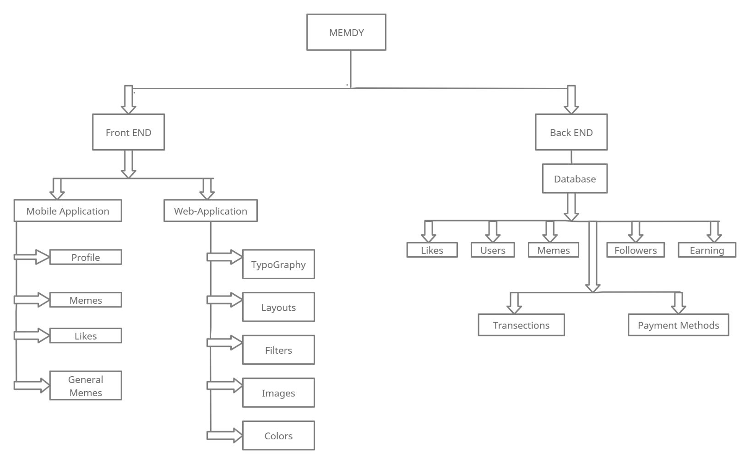Hierarchy Diagram

* 1. Use Cases

There will be two primary actors of the system. Uses cases for each actor are as below.

|  |  |  |
| --- | --- | --- |
| **S No** | **Primary Actor** | **Use Cases** |
| 1 | Memer | Signup (web-browser and Mobile Application) |
| Login (web-browser and Mobile Application) |
| Create Memes |
| Publish memes which will be added to its profile |
| Add memes to its profile |
| Can earn coin through views, likes and share |
| Manage profile |
| Add and Delete memes from its profile |
|  |
| 2 | User | Signup |
| Login |
| View Memes |
| Visit profile of Memer |
| Like, share and dislike memes |

* 1. 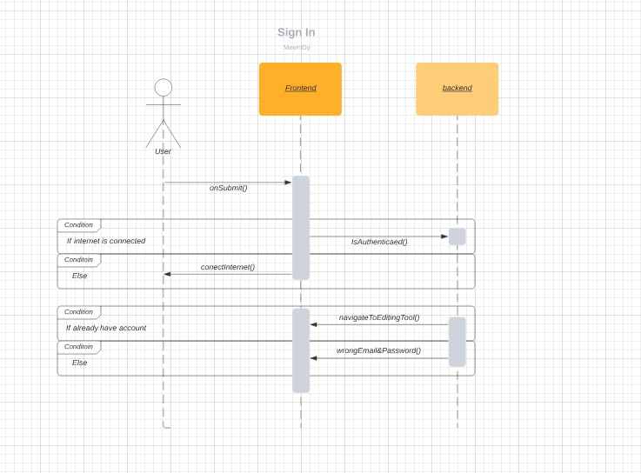User Class 1: Sign in
  2. 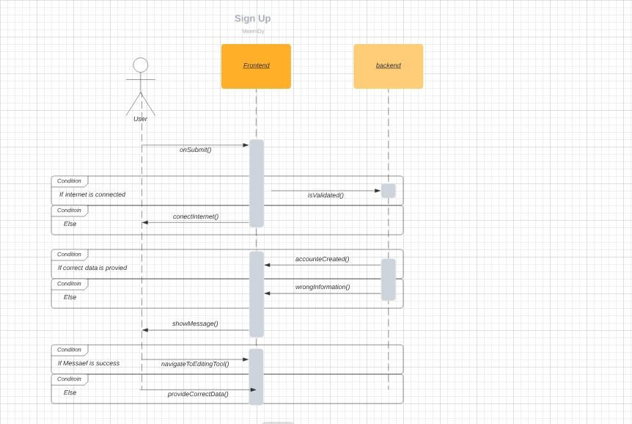User Class 2: Sign Up

|  |  |  |  |  |
| --- | --- | --- | --- | --- |
| **<Use case Id: name>** | | | | |
| **Use case Id:** | | Write use case reference number. | | |
| **Actors:**  <List of actors (external agents), indicating who initiated the use case> | | | | |
| **Feature:** <Feature from which the use case is driven> | | | | |
| **Pre-condition:** | | <List the assumptions required before this Use Case can be executed. > | | |
| **Scenarios** | | | | |
| **Step#** | **Action** | | | **Software Reaction** |
| **1.** | Numbered actions of the actors | | | Numbered description of system responses |
| **2.** |  | | |  |
|  |  | | |  |
| **Alternate Scenarios:** Write additional, optional, branching or iterative steps. Refer to specific action number to ensure understandability. | | | | |
| **1a:**    **2a:** | | | | |
| **Post Conditions** | | | | |
| **Step#** | **Description** | | | |
|  | Sequentially list conditions expected at the completion of the use case. | | | |
|  |  | | | |
|  |  | | | |
| **Use Case Cross referenced** | | | <Related use cases, which use or are used by this use case> | |

1. Non-functional Requirements

This section outlines the fundamental non-functional requirements.

* 1. Performance Requirements

This section provides detailed specification of user interaction with the system along with performance of system.

**NFR-01:** Web-application will be loaded within 5 seconds.

**NFR-02:** Mobile Application will be opened on the spot depends on internet connection**.**

**NFR-03:** From web-application memes will be added to user profile and published within 5-7 seconds.

**NFR-04:** Web-application will be opened on any web browser.

**NFR-05:** Mobile application is compatible for android version greater than 4.2.

**NFR-06:** Mobile Application will provide same functionality to both android and IOS devices.

**NFR-07:** Both Mobile Application and web-application will perform its functions accurately.

* 1. Safety Requirements

NFR-08: Any exception which occur must be handled.

NFR-09: Both web-application and Mobile Application will not be crashed while in use.

NFR-10: In case of data lose Backup must be available.

* 1. Security Requirements

NFR-11: HTTP protocol will be used.

NFR-12: web-application will be hosted on secure server which will provide security.

NFR-13: Database will be stored on Mongo BD cloud.

* 1. User Documentation

User manuals will be given when software will be delivered.

1. References
2. [*Melanie Perkins*](https://www.google.com/search?q=Melanie+Perkins&stick=H4sIAAAAAAAAAOPgE-LWz9U3MDTKyDMqN1Pi1U_XNzTMMMnLyDU0N9NSz0620k8qLc7MSy0uhjPi8wtSixJLMvPzrNLyS_NSUosWsfL7puYk5mWmKgSkFmVn5hXvYGUEALGMNKVcAAAA&sa=X&sqi=2&ved=2ahUKEwjcte3roP30AhXQUWwGHRVdC74QmxMoAXoECC8QAw)*,*[*Cliff Obrecht*](https://www.google.com/search?q=Cliff+Obrecht&stick=H4sIAAAAAAAAAOPgE-LWz9U3MDTKyDMqN1Pi1U_XNzTMSMorKcswMdZSz0620k8qLc7MSy0uhjPi8wtSixJLMvPzrNLyS_NSUosWsfI652SmpSn4JxWlJmeU7GBlBAA4Ml1eWgAAAA&sa=X&sqi=2&ved=2ahUKEwjcte3roP30AhXQUWwGHRVdC74QmxMoAnoECC8QBA)*,*[*Cameron Adams*](https://www.google.com/search?q=Cameron+Adams&stick=H4sIAAAAAAAAAOPgE-LWz9U3MDTKyDMqN1Pi1U_XNzRMMy7LLik2qdRSz0620k8qLc7MSy0uhjPi8wtSixJLMvPzrNLyS_NSUosWsfI6J-amFuXnKTimJOYW72BlBABrZbo_WgAAAA&sa=X&sqi=2&ved=2ahUKEwjcte3roP30AhXQUWwGHRVdC74QmxMoA3oECC8QBQ)*. Perth, Australia, 2013.* [*www.canva.com*](http://www.canva.com)
3. [*www.memes.com*](http://www.memes.com)
4. *Xie, L., Natsev, A., Kender, J. R., Hill, M., & Smith, J. R. (2011, November). Visual memes in social media: tracking real-world news in youtube videos. In Proceedings of the 19th ACM international conference on Multimedia (pp. 53-62).*
5. Appendices

[This section should include supporting detail that would be too distracting to include in the main body of the document.]